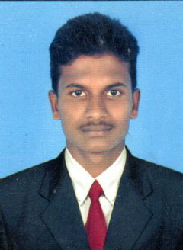
V.JAGADISH
3/62 SANTHIPURAM ,
CHITTOOR (DISTRICT)
ANDHRA PRADESH
PIN- 517423 Mob. +916304821681
Email. Jagadishjay979@gmail.com

Objective
To do join with sincerity and honesty to the best of my satisfaction, this bringing it to the benefit of the organization self and the honest.
PersonalSkills
Hard worker with excellent verbal and written communication skills ability to Deal with people Technical, willingness to learn.
Academic Qualifications
- Pursuing 2nd Year Degree in Hotel Management Chenna's Amirta IIHM- OMR, Chennai
- completed +2 Govt Junior College Santhipuram 60%
- completed SSC. GHS SNTHIPURAM 55%

Strengths
- Able to work efficiently and skillfully in a group as well as individually
- Energetic and self-motivated
- Ability to learn and hardworking
- Work in more intense pressure
- Food and Beverage
- Bar and Restaurant

Experience

Personal Info
Father : Venkatachalam
Date of birth : 13-08-2000
Gender : Male
Marital status : Single
Religion : Hindu
Nationality : Indian
Languages knows : English;Telugu Thamil& Kannada.
Hobbies : playing games,

Declaration
I hereby declare that all the above information furnished by me is correct to the best of my knowledge.

Date: Yours Sincerely,
Place: Andhrapradesh
(V.JAGADISH)

